**Basic Operation on images**

clc;

clear all;

close all;

a=imread('C:\Users\Public\Pictures\Sample Pictures\aa.jpg');

A=imresize(a,[240 240]);

% IMAGE 1

figure,imshow(A);

title('IMAGE 1');

subplot(2,2,1);

% Cropped Image

a1= imcrop(A);

subplot(2,2,2);

imshow(a1);

title('Cropped Image');

imtool(a1);

% Grayscale Image

a2=rgb2gray(A);

subplot(2,2,3);

imshow(a2);

title('Grayscale Image');

% Histogram

subplot(2,2,4);

imhist(a2);

title('Histogram');

% IMAGE 2

b=imread('C:\Users\Public\Pictures\Sample Pictures\Tulips.jpg');

B=imresize(b,[240 240]);

figure,imshow(B);

title('IMAGE 2');

%

% ADDITION

c=imadd(A,B);

figure,imshow(c);

title('ADDITION');

% SUBTRACTION

d=imsubtract(A,B);

figure,imshow(d);

title('SUBTRACTION');

% MULTIPLICATION

e=immultiply(A,B);

figure,imshow(e);

title('MULTIPLICATION');

% DIVISION

f=imdivide(A,B);

figure,imshow(f);

title('DIVISION');

% Rotated Image

g=imrotate(A,90);

subplot(3,2,6);

imshow(g);

title('Rotated Image');

% And operation

and1= bitand(A,B);

figure

subplot(3,2,1);

imshow(uint8(and1));

title('And operation');

% Or operation

or1=bitor(A,B);

subplot(3,2,2);

imshow(uint8(or1));

title('Or operation');

% Xor operation

xor1=bitxor(A,B);

subplot(3,2,3);

imshow(uint8(xor1));

title('Xor operation');

% Complement of First image

comp1=imcomplement(A);

subplot(3,2,4);

imshow(comp1);

title('Complement of First image');

% Complement of second image

comp2=imcomplement(B);

subplot(3,2,5);

imshow(comp2);

title('Complement of second image');

OUTPUTS :

**Features of image** :

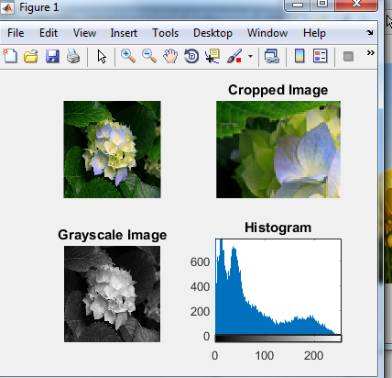

**Cropping of image1 and using tool command to see the pixel value of image :**

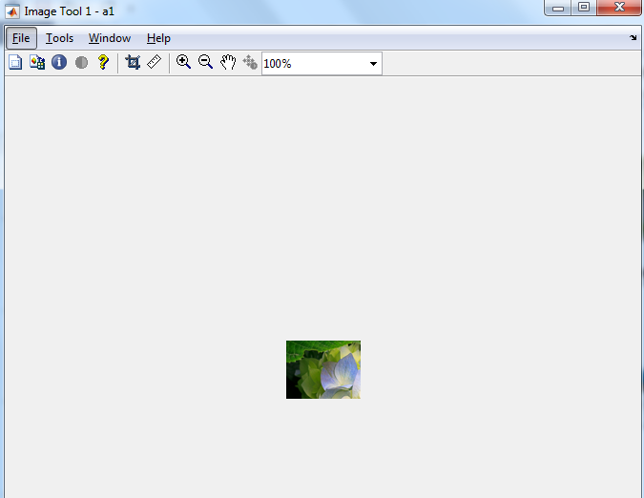

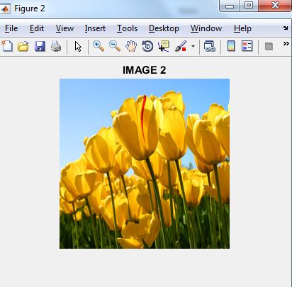

ARITHMETIC OPERATIONS

Addition of image 1 and image 2 :

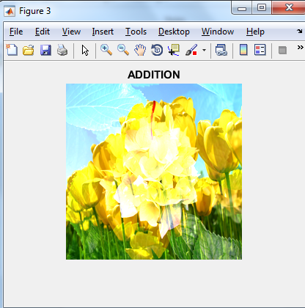

Subtraction of image 1 and image 2 :

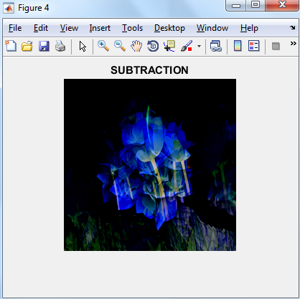

Multiplication of image 1 and image 2 :

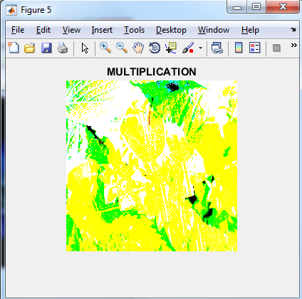



Logical operation on images

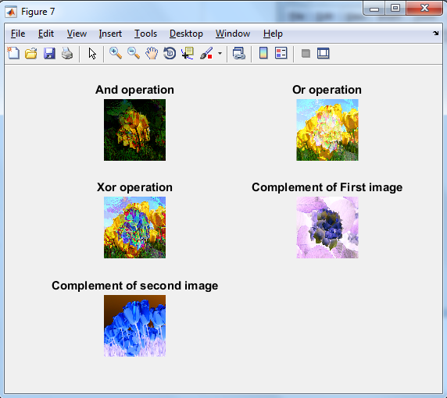

(b) when logical operation are performed on binary images

clc;

close all;

clear all;

for i=1:32

for j=1:32

if((rem((i+j),2)==0))

g(i,j) = 0;

else

g(i,j) = 1;

end

end

end

figure,

subplot(3,2,1);

imshow(g);

title('Binary Image 1');

%Image 2

for i=1:32

for j=1:32

if(rem(i,2)==1)

h(i,j) = 1;

else

h(i,j) = 0;

end

end

end

subplot(3,2,2);

imshow(h);

title('Binary Image 2');

i = g & h;

subplot(3,2,3);

imshow(i);

title('Logical AND');

j = g | h;

subplot(3,2,4);

imshow(j);

title('Logical OR');

k = xor(g,h);

subplot(3,2,5);

imshow(k);

title('Logical XOR');

output :

